**Περιγράφουμε τον Πινόκιο**

-Συμπλήρωσε τον πιο κάτω πίνακα. Μετά γράψε μια

παράγραφο για να περιγράψεις εξωτερικά τον Πινόκιο.

|  |  |  |
| --- | --- | --- |
| μύτη | μακριά | σαν ραβδί μάγισσας |
| μάτια | μεγάλα, γαλανά |  |
| φρύδια | καμαρωτά |  |
| μέτωπο |  |  |
| στόμα |  |  |
| μαλλιά |  |  |
| αυτιά |  |  |
| πρόσωπο |  |  |
| πόδια και χέρια |  |  |
| κορμί |  |  |

[](http://images.google.com/url?source=imgres&ct=tbn&q=http://urbanpoetic.files.wordpress.com/2009/04/pinocchio.jpg&usg=AFQjCNELH1qoWUBKkrLQKnUyjuiC5053OA)

_________________________________________________________________________________________________________________________________________________________________________________________________________________________________________________________________________________________________________________________________________________________________________________________________________________________________________________________________________________________________________________________________________________________________________________________________________________________________________________________________________________________________________________________________________________________________________________________________________________________________________________________________________________________________________________________________________________________________________________________________________________________________________________________________________________________________________________________________________________________

[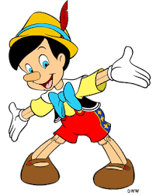](http://images.google.com/url?source=imgres&ct=tbn&q=http://www.vpinokio.gr/Nipiagogio/images/pinokio.gif&usg=AFQjCNE0LV8N-IXnLdL_ZZ2WQiY_If5spQ)